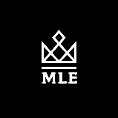

Make Life Luxury (client)

Make Life Exclusive was founded in NY by two brothers with the mission of creating a strictly exclusive line of products for men. There entire mission is to provide men with great hair quality products after building some great rapport with the client we felt like we can help them achieve the goal of launching the prodcut on social media effectively int eh next 45 days.

Current Situation I

Zero social media presence and no strategy for launching their products into the marketplace.

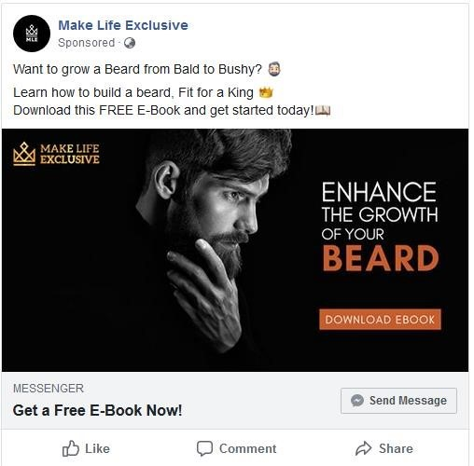
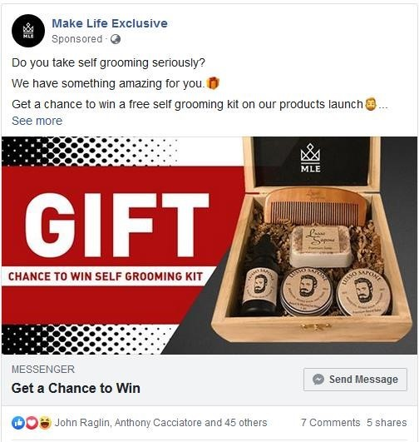
WHAT WE DID Ii

After our 45-minute consultation call, we analysed their target audience, and decided to work on building their social media presence just before product launch which would happen 45 days from the first call, we had with them.

After spending a week thoroughly researching and understand MLEs market segment, we drew up our social media marketing strategy which included, 9 posts a week on FB and IG as well as doing eBook giveaways with FB messenger.
Our main goal was to use this strategy to collect customer emails and data, in order to launch to a warm audience i.e create a campign on Facebook and use this information to launch to a custom audience which would lead to more sales. On the right you can see our first ad copy.

We then tested the ad copy, images and target audiences and ran for few days which resulted in us finding our winning ads. We got a CPA $1.48.

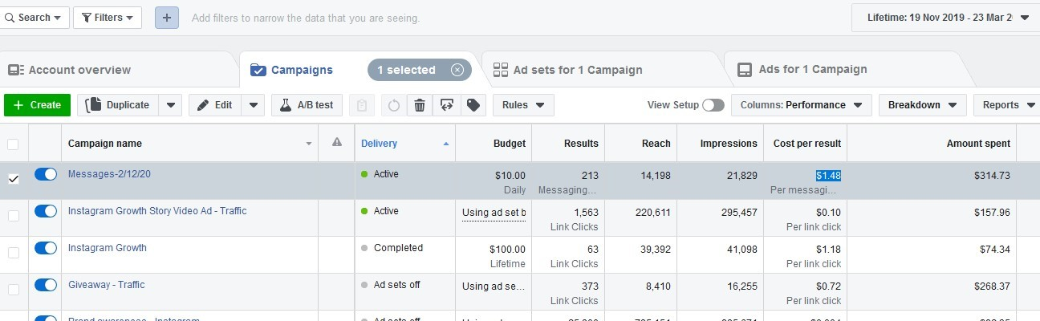

That’s 213 customers for only $1.48 per customer email in less than 45 days. Now they are ready to launch to a warm audience using the 213-customer data as a base to target others on social media.
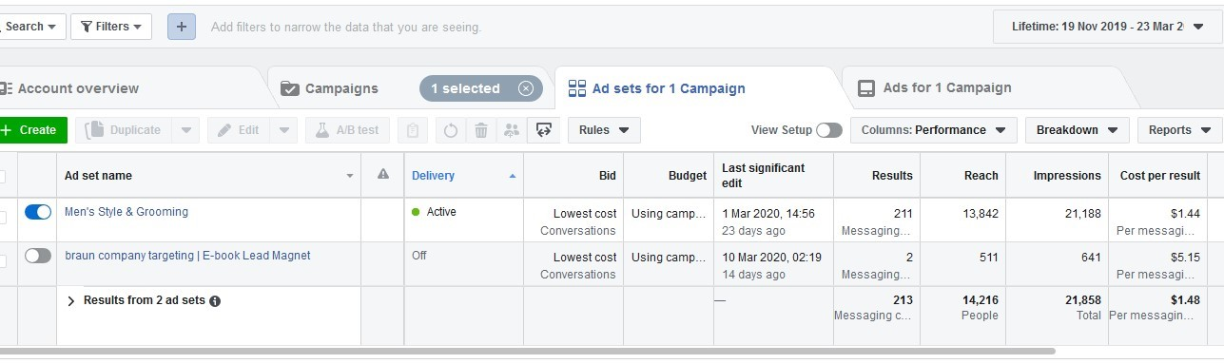

Social Media Growth Ii

When MLE came to us, they had 0 social media presence and no strategy to get a targeted following going on IG or
FB. This is what we did after our 45-minute free consultation call with Scott co-founder or MLE.
We conducted a through competitive analyses and created a fully in-depth social media marketing strategy and then executed immediately after Scott was happy with our strategy. Here is our 7-step process for building an engaging following for MLE.

Social media marketing strategy link - https://docs.google.com/document/d/16XjoO3o8LfahB2OLdRkh7hQVdBeymsDCL_igAFmi-kM/edit

Competitive analysis link –
https://docs.google.com/spreadsheets/d/1_QqbyMBtfry2TvCJ3uV1ACtrE7-xek0xbP4D__48bwc/edit?usp=sharing

Step 1: Create Marketing Goals
to Solve Your Biggest Challenges

Some of the goals we took look at for MLE.
Increasing Brand Awareness
Creating a Loyal Fanbase
Step 2: Research Your Social Media Audience
We looked at all the social platforms and we figured based on MLEs customer avatars , IG would be the most important platform for organic reach and most of their target audience would be based on IG due to age and customer demographics.
Step 3: Establish Your Most
Important Metrics

We knew MLE were not after sales because they hadn’t launched yet, so we figured our most important metrics were, Reach and Relevance.

Step 4: Research Your Social
Competitive Landscape

As you can see on the link above, we always carry out a competitive analysis and we did for MLE as well and then we focused on what kind of content would work based on their competitors.
Step 5: Build & Curate Engaging
Social Media Content

We curated all the content, as MLE had no products out yet we did all the graphic design in house as well as the content.

Step 6: Engage with Your
Audience

We made sure all comments were answered on all of their social media pages to ensure engagement as well as helping their pages with ranking.

Step 7: Track Your Efforts &
Always Improve

We used Hootsuite and IG, FB analytics to analyse our data and improve every single week.

